Government College of Engineering, Jalgaon.
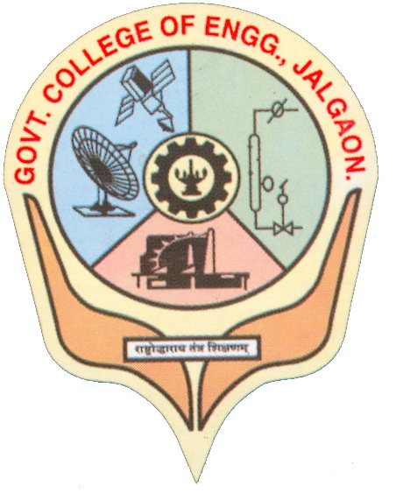
National Highway No. – 06, Jalgaon, Pin-425002.
Phone:02572281522; Fax 02572281319;
Web:www.gcoej.ac.in; email:princoej@rediffmail.com

Application for Degree Certificate

Date:-

To,
The Dean Academics,
Government College of Engineering, Jalgaon - 425002
Subject:- Request to issue Final Degree Certificate

Respected Sir,
PRN ............................., Name .........................................................................................of a ...........................................Branch . I have studies in this esteemed institute from ........................ . I have successfully completed my graduation at ............................ examination. So I would kindly bring to your request to issue my Degree Certificate which is received from KBC North Maharashtra University, Jalgaon .
Thanking You.

Enclosure:
- Photocopy of TC
- Photocopy of Identity Card
- Photocopy of Provisional Degree Certificate
Yours Faithfully,

Signature of the Candidate
Name:-
Mobile No:-

